OWASP Juice Shop

Emily Lovo
University of Advancing Technology
NTS330: Applied Exploits
Sarah Bunce

OWASP Juice Shop

Introduction
The OWASP Juice Shop is an awesome open-source project created by the OWASP Foundation to help people learn about web security by mimicking real-world vulnerabilities. It’s a great platform for understanding the kinds of security weaknesses that can pop up in modern web applications. Built mostly with JavaScript and TypeScript and running on a Node.js backend, it’s a handy tool for both developers and security buffs.
Recently, I worked on a project using the Juice Shop application. I started by downloading it from the official GitHub repository, where you can find the source code and documentation. Since Kali Linux is packed with great security tools, I decided to install it there. The installation was super easy. I just ran the command `npm install` in the terminal. This downloaded all the necessary packages and set up everything I needed, giving me access to the source code and documentation explaining how the app works.
To get the app up and running, I executed `npm start,` which fired up the server. Then, I accessed Juice Shop locally through my web browser at `http://localhost:3000`. This setup allowed me to explore the different vulnerabilities the Juice Shop was designed to showcase in a hands-on way.
While exploring, I looked into various security issues like insecure cookie management, improper input validation, and problems with session handling. I also checked out runtime features that pointed out potential vulnerabilities that could be exploited while the app was running. To deepen my analysis and get a better grip on the security issues, I used penetration testing tools like Burp Suite and OWASP ZAP. These tools were super helpful because they let me scan for vulnerabilities, intercept requests, and tweak parameters to find hidden issues, which really boosted my understanding of web security best practices.

Scoreboard
I've noticed that the OWASP Juice Shop is a vulnerable website. It's designed to demonstrate various vulnerabilities to people interested in web security. The website is open-source and maintained by OWASP. I downloaded it on Kali Linux and followed the installation steps, which involved using npm install and npm start. After that, I accessed the website localhost:3000.
I first started by using developer tools to inspect the code. I would right-click and select "inspect" or "view page source." When I looked at the page source, I could see the different JavaScript, which helped me understand what to do next. I had to inspect and look at each JavaScript and try to understand it. To make it easier to read, I used a website to beautify JavaScript. I noticed that the scoreboard was under JavaScript runtime, but I couldn't figure out how to make the runtime work so that the scoreboard would show up. I was wondering if the scoreboard was only in runtime because it's based on your runtime. It calculates how to add it to the scoreboard, but I wasn't completely sure. However, it did work, and it presented me with different challenges, although I was mainly focused on the scoreboard. I saw many different things in the runtime beneath JavaScript, including hints within the code, but I was unsure about how to proceed.
I used Burp Suite to intercept and analyze the traffic between the browser and Juice Shop. I tried to identify any hidden clues and points in the requests and responses, but I found insecure cookies and invalid input fields. These findings helped me understand one of the beginner challenges. I also used OWASP ZAP in class to explore Juice Shop and identify cross-site scripting vulnerabilities, but these tools didn't help me find the scoreboard. Instead, they led me to discover other challenges and gain a preview of different things I can find in Juice Shop.
The last thing I did was ask ChatGPT to give me URL suggestions for paths to access. First, I tried "scoreboard," then "challenges," but nothing happened. It just kept me on the same home screen without changing the URL. So, I thought that maybe in the sources tab, when I looked up "scoreboard," I saw that there was a path "/score-board" in the URL. When I typed it into the URL, it allowed me to see the scoreboard and all the different challenges and progress that I had made. Because I didn't type in these URLs or complete any of these little challenges, apparently, it didn't count. Thanks to that, it gave me different suggestions for where to look because I mentioned that I tried to use Burp and ZAP, but I couldn't find the scoreboard. So, it recommended I use path guessing, and when I used path guessing instead, I found out that one of the source tabs, which I missed, was a URL path, and that's what got me to see the scoreboard.
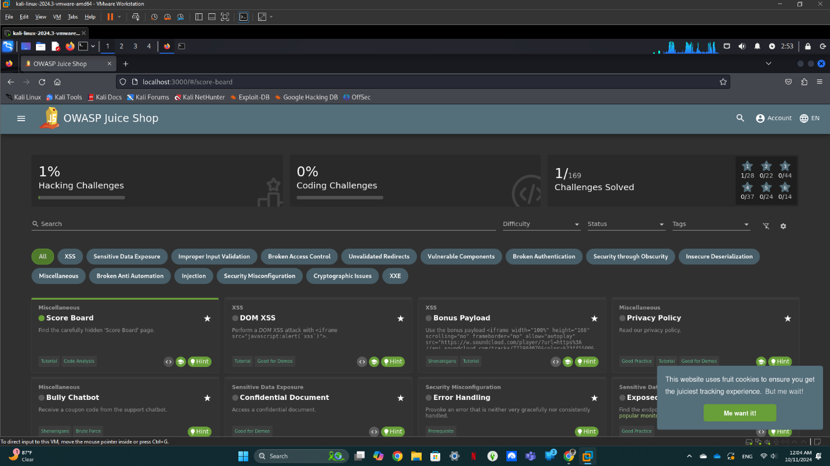

Login MC SafeSearch
The first thing I did for the login was to check all the reviews, as the professor suggested. I looked at the pictures to see if there were any reviews, and I found it helpful to start with the reviews to see if I could get the email. Fortunately, I did find MC's email under review for the Juice Box Permafrost 2020 Edition. He left a comment that said, "Let It Go, Let It Go." I noticed that these were lyrics, which made me wonder why someone would use song lyrics in their reviews. I thought he was a musician. Out of curiosity, I looked him up and found a music video featuring a song called "Protect Your Password." In the video, he mentioned that he described his password as "Mr. Noodles," which is the name of his pet. It seemed a bit tricky because instead of using Os, he substituted zeros. I tried that approach, but when I input "Mr. Noodles" altogether, it didn't work. After "Mr.," there needs to be a space. I didn't realize he was a musician until I asked ChatGPT about who MC is, and he suggested I watch the video called "Protect Your Password." As I listened to the entire song, I noticed that MC mentioned his password.
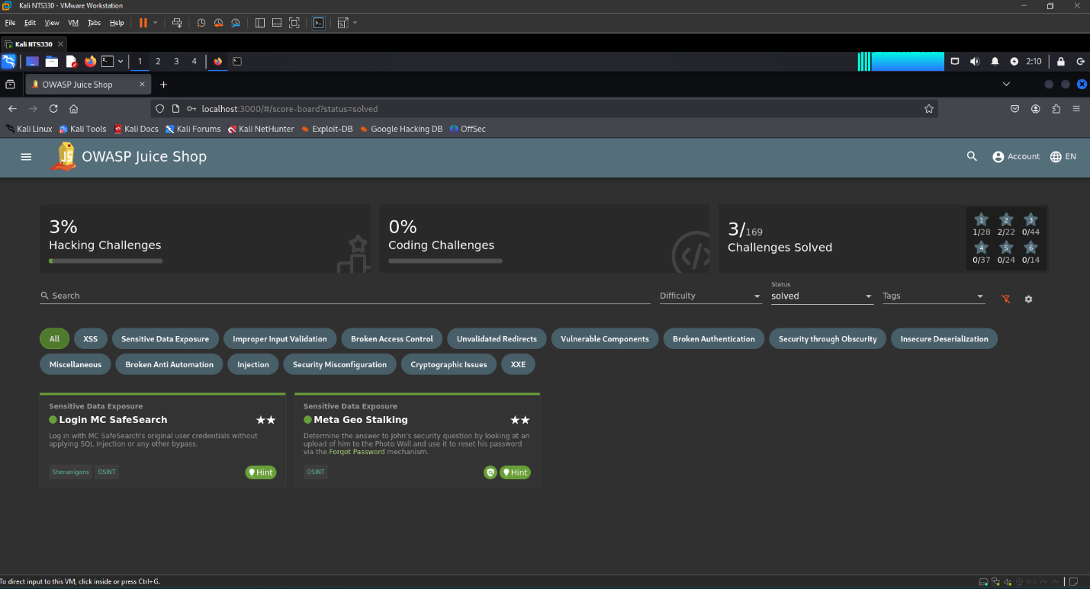

Meta Geo Stalking
Thanks to the tip, I already knew his email, so I went to the "Forgot Password" option. I saw that his security question was, "Where is my favorite place to hike?" Following Sarah's suggestion, I checked the photo wall and looked at the pictures. I used a website called photo-forensics.com to extract information from an image. With that, I discovered another suggestion from ChatGPT about using a tool called `sudo apt install libimage-exiftool-nerl,` which retrieves metadata in a similar way to Photo Forensics but through the command line. This way, I could view the metadata directly. Since we were looking for a specific location, we focused on the GPS coordinates. At the bottom of the command line, I found the GPS position. I copied and pasted the coordinates into Google Maps. Once I hit enter, I saw a bunch of random green areas and roads. After analyzing the map, I identified the location as Daniel Boone National Forest, which is his favorite place to hike, as he had posted on the photo wall. Using this information, I changed his password to a simple one: P@ssw0rd. After confirming the change, I completed the challenge.

Admin Account and Forged Feedback
I first completed the administrative tasks demonstrated in class by downloading the SecLists and then using the Wfuzz command to find the password for the admin account. Next, I worked on forging feedback. To do this, I first created a username and then examined the cookies in storage. I noticed the different sessions and used ZAP to change the rating or alter the user ID, which allowed me to forge feedback under an account that wasn’t mine.

View Basket
For the “View basket” task, I logged in as an admin and checked the basket’s session ID in storage. I changed the value to any number, reloaded the page, and found items in my basket.

Five Star Feedback
For the five-star feedback, I followed a process similar to that of the admin feedback. I first logged in and accessed the admin section. It’s important to be logged in as an admin for this. After entering “Administration” in the search bar after the slash, I could see the registered users. To complete the task, all I needed to do was delete a five-star review.
I required help for the majority of these tasks, except for the first two demonstrated in class. For the other two, I had to search online for guidance on how to start, but once I knew where to look, I was able to navigate the process myself.
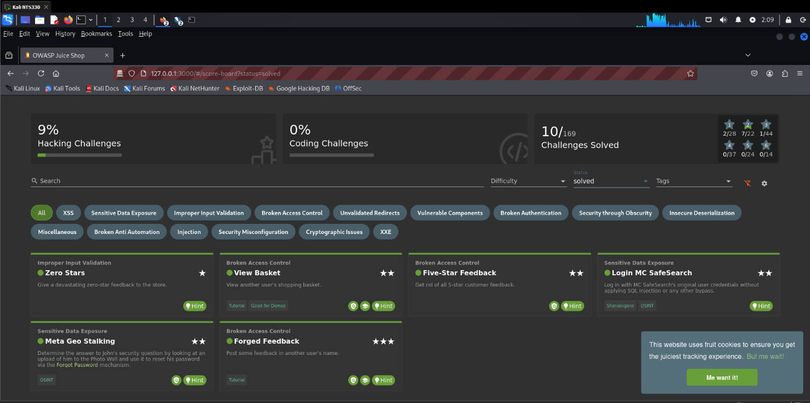

Error Handling
I used the suggestion to use DirBuster for error handling. First, I had to install it and then remember how to use it. Thankfully, I found a basic rundown of the commands I could use. I started by typing in the URL of the target I wanted to access. Next, I chose one of the word lists provided within the tool. After selecting a word list, I opted for a medium scan and specified certain file extensions to look for, including PHP, HTML, TXT, and LOG. I set the number of threads to 50 and then initiated the scan. While the scan was running, I noticed that numerous errors were appearing. At some point, the program paused after reaching about 20 errors, eventually showing a green banner indicating that the scan was complete. Although I'm not entirely sure what that meant, it found several errors during the process. Additionally, one of the files it discovered was a "security.txt." Overall, this is how I approached error handling using DirBuster.

Deprecated Interface
For the deprecated interface, it instructed us to use a B2B interface, but I wasn't sure what that meant. So, I asked for clarification and received a summary explaining it on ChatGPT. I learned that I needed to look for software components that are either no longer supported or have known vulnerabilities. Using Recon, I discovered that I didn't need to exploit anything to find issues; I just had to observe and gather information. I was advised to pay special attention to areas where file uploads are allowed since these are often rich in vulnerabilities. I went to the complaints section and found that only PDFs and ZIP files were permitted to be uploaded. What if I could upload a different file type? I experimented with images and documents, but they didn't work. Then, I checked the system's allowed file types and saw that XML files were permitted. I created an XML file and uploaded it to the complaints section, which was successful. At first, I felt lost and didn't know where to begin, but I received suggestions to conduct reconnaissance and focus on anything that might be outdated. The areas allowing uploads could potentially harbor more vulnerabilities. I found it quite intriguing—and somewhat alarming—that while there were restrictions on file types, there were still loopholes that could expose vulnerabilities. Overall, I found this experience to be both interesting and concerning.
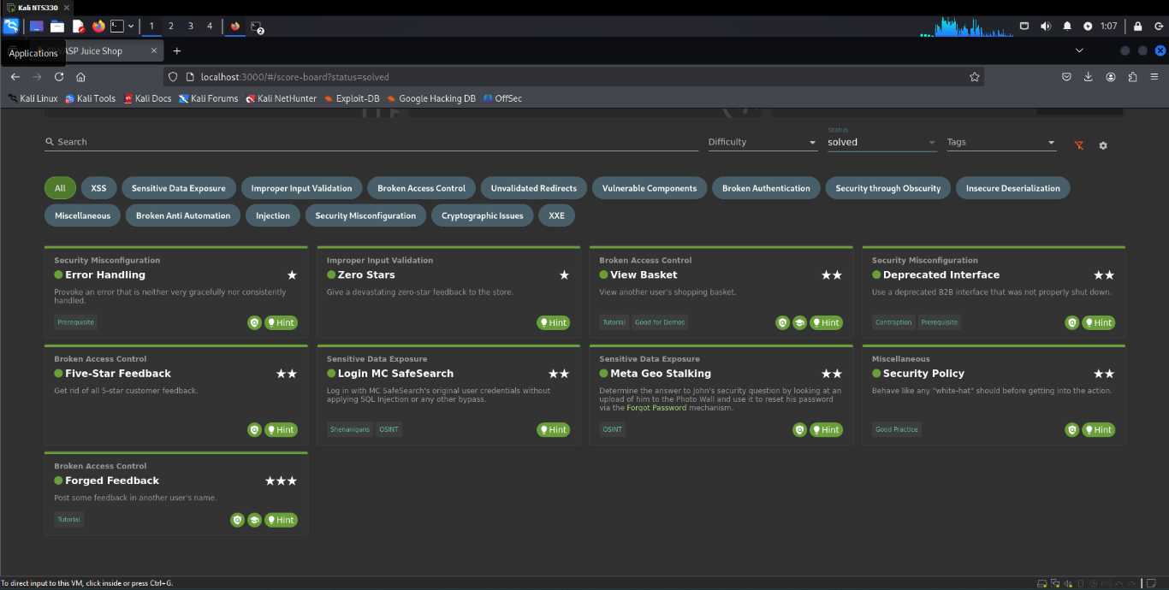

DOM XSS
For the assignment on DOM-based XSS, I initially tried using the default XSS payload, which involved a simple JavaScript alert. Unfortunately, that approach didn’t work. So, I looked for clues regarding the correct script to use. I discovered that if the default payload fails, there is a specific script you can use that is more effective. I copied and pasted that script, and it successfully triggered the alert. It was exciting to bypass the security measure by entering it into the search bar. I believe that if I continue to learn more about cross-site scripting, I will find it even more interesting and will uncover more techniques like this one.

Bonus Payload
While I was looking at the achievement for cross-site scripting, I noticed there was a bonus payload achievement that I wanted to pursue. I copied and pasted a description that mentioned a script needed to unlock the Juice Shop jingle. This script automatically opens SoundCloud and starts playing the jingle. I need to do much more research on how the script specifically works, or I could look for an explanation of its mechanics. I found it really interesting that by simply entering this script into the search bar, you could listen to the jingle.
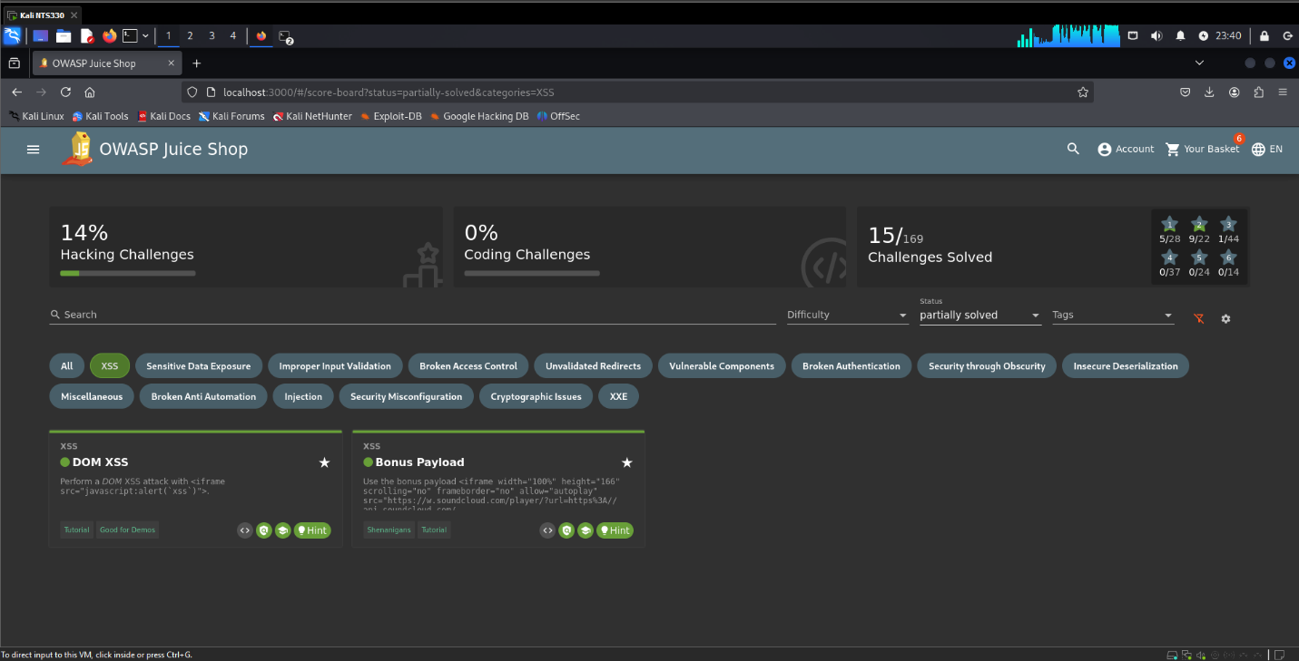

References
OpenAI. (2024). ChatGPT [Large language model]. https://chatgpt.com
OWASP Juice Shop. OWASP Juice Shop | OWASP Foundation. (n.d.). https://owasp.org/www-project-juice-shop/

