IoT Smartphone Application Analysis of iGoat-Swift

Emily Lovo
University of Advancing Technology
NTW233: IoT Security and Architecture
Briant Becote
7/17/2025

Executive Summary
This report provides a security analysis of the "IGoat-Swift" mobile application using the Mobile Security Framework (MobSF) within a Docker container on my Kali Linux setup. "IGoat- Swift" is an intentional vulnerability application designed to educate cybersecurity students, professionals, and developers about iOS security. The analysis focuses on various forms of memory corruption, including buffer overflows, use-after-free vulnerabilities, dangling pointers, and integer overflows. It also discusses mechanisms for memory safety, such as stack canaries and Automatic Reference Counting (ARC). I will cover the different vulnerabilities identified, their implications, and some strategies to mitigate these issues and enhance mobile app security.

Tools and Setup
I downloaded the latest version of Docker on Linux and used MobSF with the application. I accessed it through the link provided, using "mob SF" as the username and "mobsf" as the password. Once MobSF was launched, I extracted the IPA file from the GitHub source and uploaded it to the MobSF interface for analysis.
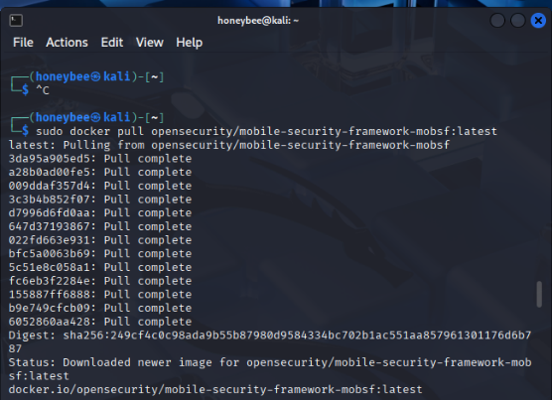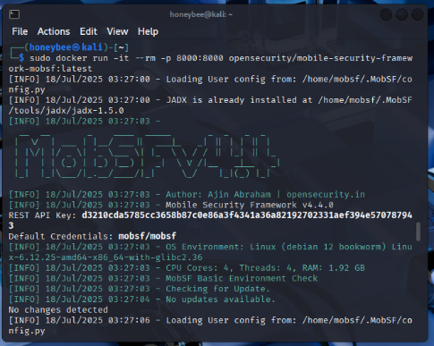

Memory Corruption Vulnerabilities
Memory corruption vulnerabilities occur when software incorrectly modifies memory, allowing attackers to exploit the system. iOS apps, typically written in Objective-C and Swift, are vulnerable to these issues, especially when they are compiled without protective features. The four main types of vulnerabilities I will address are buffer overflows, use-after-free, dangling pointers, and integer overflows. Buffer overflows occur when more data is written to a buffer than it can accommodate, causing it to overwrite adjacent memory. This can lead to application crashes and the execution of arbitrary code. A use-after-free vulnerability occurs when a program continues to use memory that has been released. If an attacker gains access to this memory, they can inject malicious data into it and potentially hijack the application's execution flow. Dangling pointers refer to memory locations that have already been deallocated. Accessing these pointers can lead to unpredictable behavior, such as crashes or memory leaks. Finally, integer overflows occur when a value exceeds the storage capacity of its data type. This can lead to miscalculations in memory allocations, which may result in buffer overflows.

Stack Canary and ARC
Stack Canary is a security mechanism that is placed between a buffer and control data on a stack. It is used to detect and prevent stack-based buffer overflows. If the canary value is altered during runtime, the program will terminate execution to prevent exploitation. The report notes that stack canaries were not enabled during compilation. ARC (Automatic Reference Counting) is a memory management system used in Swift and Objective-C programming languages. It automatically frees the memory used by objects that are no longer needed. When ARC is disabled or misused, vulnerabilities such as memory corruption, use-after-free errors, and memory leaks become more likely to occur. The report mentions that ARC was not enabled during the Swift build process.

MobSF Analysis Results
After analyzing the static analysis of the Mob SF code, I noticed several significant issues. First, the static Canary production was absent, and Arc memory management was disabled. Additionally, there are hard-coded sensitive strings in the URLs, which pose a potential risk for exploitative intents and permissions. I also found improper binary entitlements, as well as embedded insecure domains and URLs. These are just a few of the findings I highlighted, as the system appeared deliberately vulnerable. Overall, this analysis provided a valuable case study on how memory management works and its associated flaws.

Mitigation Strategies
To enhance the security of your builds, consider implementing various strategies. First, enable compiler-level protections and ensure that the built-in protections are active for all your build targets. It is advisable to enable Arc (Address Randomization Configuration) across all targets; online resources are available for guidance on this process. “Next, avoid using unsafe C functions such as `gets`, `strcpy`, and `strcat`. Instead, opt for safer alternatives, such as `strncpy` and `snprintf`.” Additionally, ensure that you validate all input data before writing it to memory buffers. This practice helps prevent untrusted data from entering your system. Finally, integrate tools like Mob SPF or similar into your development pipelines. These tools will regularly test your compiled builds to identify and rectify any flaws before you release them to the app store.

Reflection and Thoughts
I found running the MobSF tool in Docker to be very effective. The only issue I encountered was not having Docker installed on my Kali VM, but I resolved it quickly by downloading and installing it. I appreciated that the tool provided a detailed breakdown of all the vulnerabilities, clearly indicating a lack of memory safety measures in the IGoat binary. The output was straightforward, allowing me to connect these vulnerabilities to real-world examples. It was great to see how security controls can be applied at every stage of mobile development in the iOS lifecycle, just as you would in Android or any other type of mobile development.

Appendix
MobSF Report

References
Apple. (n.d.). Automatic Reference Counting. Swift.org. Retrieved July 18, 2025, from https://docs.swift.org/swift-book/documentation/the-swift-programming-language/automaticreferencecounting/
OWASP. (n.d.). iGoat-Swift. GitHub. Retrieved July 18, 2025, from https://github.com/OWASP/iGoat-Swift
RunSafe Security. (2022, September 1). Memory Safety Vulnerabilities: Understanding and Preventing Them. RunSafe Security. https://runsafesecurity.com/blog/memory-safety-vulnerabilities/
Schroeder, W. (2021, July 21). Stack Canaries: Gingerly Sidestepping the Cage. SANS Institute. https://www.sans.org/bNo index entries found.log/stack-canaries-gingerly-sidestepping-the-cage/
ChatGPT

