IoT Device Security Analysis Report

Emily Lovo
University of Advancing Technology
NTW233: IoT Security and Architecture
Briant Becote
8/21/2025

Introduction
The Zoe Touch Smart Bathroom Scale is a consumer Internet of Things (IoT) health device designed to measure weight and body composition, including BMI, muscle mass, and fat percentage. This device connects via Bluetooth Low Energy to the Zoe Touch Health mobile app, allowing users to track their data over time and sync all information with Apple Health and Google Fit. This report provides a security analysis of the Zoe Touch Smart Bathroom Scale. The scope of this analysis includes the framework, hardware, smartphone application, and wireless communications. We primarily conducted open-source research and a static analysis of the Zoe Touch Health APK. Additionally, we performed a hardware teardown and threat modeling.

Device Details
The manufacturer is Shenzhen Fuguang Electronics Ltd. The model number is 9-JU15NA15. It features Bluetooth Low Energy (BLE) connectivity within the 2.402 to 2.48 GHz range, with an output of 0.52 dBm and a PCB trace antenna. Three AA batteries power the device and can collect up to 14 biometric measurements, including height, BMI, body fat, and muscle mass. The mobile app, called Always Touch Health, is integrated with Apple Health and Google Fit.

Threat Model
Using Stride, we identified several risks that pose significant security threats requiring immediate attention. These include spoofing, which involves BLE pairing hijacking; tampering, referring to unauthorized modifications of the system, such as reflashing an unsigned framework; and repudiation, characterized by a lack of adequate logging that could lead to disputes over actions taken within the app. Additionally, we found information disclosure risks, particularly with unencrypted Bluetooth Low Energy (BLE) or cloud synchronization, that could expose sensitive data. There is also the risk of denial-of-service attacks caused by BLE flooding or framework corruption, which disrupts service availability. Finally, elevation of privilege can occur when an ADB backup is abused due to settings that allow backups (allowBackup=true). These vulnerabilities collectively highlight the urgent need for enhanced security measures.

Firmware Analysis
The firmware analysis reveals several vulnerabilities: we have an unsigned firmware, no secure boot, and a lack of enforcement for digital signatures. This means that over-the-air (OTA) updates could be tampered with. Additionally, debug access through UART pads poses a risk for framework dumping and reflashing. Moreover, there is a lack of cryptographic verification, which allows for the possibility of malicious frameworks being run on this device.

Application Analysis
We conducted a static security test on the Zoe Touch Health APK using the QARK tool. The results indicated that the application contained embedded API keys and research files, as well as insecure backup permissions specified as "allow backups" in the Android manifest. Additionally, there was a single task load mode that could enable task poisoning.

Wifi Traffic Analysis
The ZoeTouch Smart bathroom scale does not have Wi-Fi capability, which means it communicates solely via Bluetooth. As a result, Wi-Fi applications are not applicable. BLE packets can reveal advertising packets with static MAC addresses that enable tracking. There are accessible characteristics without any required encryption, which increases the risk of replay attacks if session keys are reused. The scale supports Bluetooth 4.0, which includes basic encryption and ECDH pairing. However, the effectiveness of these security measures is inconsistent; they either work or they don't. This pairing method leaves the system vulnerable to potential issues such as sniffing, replay attacks, and man-in-the-middle attacks.

Hardware Analysis
We researched the vendors' listings, the FCC filings, and the App Store descriptions. The ZoeTouch Scale was found to be operating over Bluetooth Low Energy (BLE) without support for Wi-Fi or Ethernet. The FCC reports confirm that it has a PCB trace antenna with a transmission output of 0.52 dBm. However, the reports do not provide details about encryption enforcement, and the manual provides minimal information regarding the device's security features.
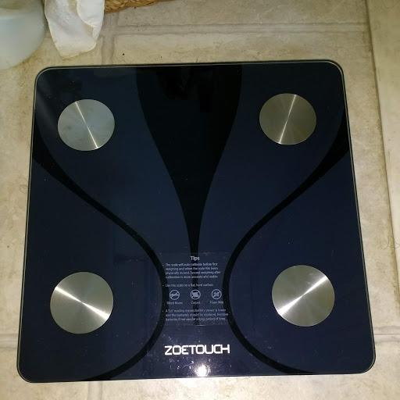

Visual Inspection
The device is equipped externally with four load cells, which can measure additional loads on its surface. It features an LED display and a battery compartment powered by three AA batteries. There are no external ports, indicating that the device likely has internal UART pads for debugging. Additionally, there are no visible tamper seals or protections.
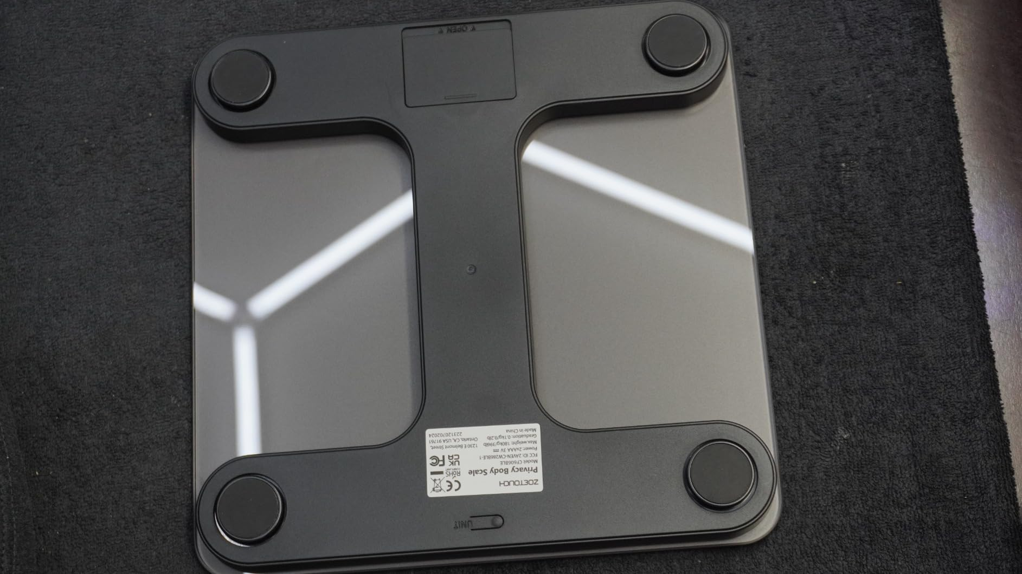

Disassembly
Based on OSINT and previous teardown references, the main board contains a System on Chip (SoC) with Bluetooth Low Energy (BLE) radio, NAND flash memory, and unprotected test pads. Previous reports indicate that the primary exploitation is possible through the UART. The system operates on an unsigned framework, which poses a risk as the framework can be extracted via the UART. This lack of signature validation allows for potentially malicious firmware flashing.
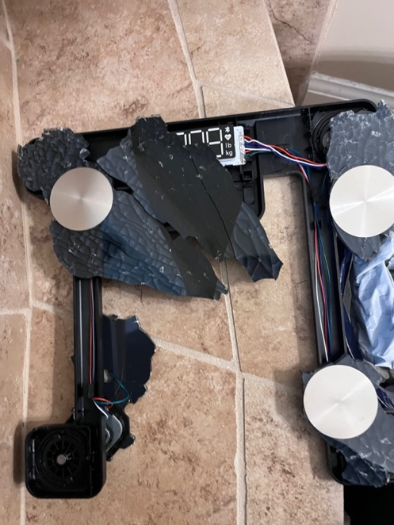

Recommendations for Mitigation
For the recommended strategies on the hardware side, you should prevent or disable epoxy from covering the ports and ensure that the MCU reads out protection fuses. It is important to implement a secure boot process with cryptographic checks for Over-The-Air (OTA) framework updates. Additionally, consider adding tamper-evident seals and encrypting local flash storage in the wireless module. To enhance security, avoid forcing secure connections that may be vulnerable to man-in-the-middle attacks. Randomize MAC addresses to prevent long-term data tracking and require frequent re-authentication to block hijacking attempts. For the mobile application, remove embedded API keys and utilize a secure key store or backend for managing secrets. Disable backups by setting the "allow backups" parameter to false, and replace single tasks with safer launch modes, such as standard or single-top, with explicit task affinity. Implement certificate pinning for all cloud communications. Lastly, in operational practices, provide clear user education on secure pairing methods and publish transparent policy practices, including retention rules and compliance configurations.

Recommendations for Further Research
The recommendations for further research include conducting a penetration test on the framework and the Bluetooth Low Energy (BLE) pairing process. It would also be beneficial to perform a dynamic analysis of the app during runtime to identify any logical flaws. Additionally, investigating the cloud API for both front-end and back-end vulnerabilities is crucial. Exploring the integration of secure elements for low-cost IoT devices should be prioritized, along with ensuring privacy compliance throughout the entire data lifecycle.

References
Amazon. (n.d.). Zoetouch smart bathroom scale for body weight, digital weighing scale with BMI, body fat, and muscle mass, Bluetooth-enabled machine for individuals, compatible with an app, and a 14-body composition analyzer. Retrieved August 17, 2025, from https://www.amazon.com/dp/B0D91Y3BBZ
APKPure. (n.d.). ZOETOUCH Health App. Retrieved August 17, 2025, from https://apkpure.com/
GitHub. (n.d.). Qark by LinkedIn. Retrieved August 17, 2025, from https://github.com/linkedin/qark
National Institute of Standards and Technology. (2012). Guide for conducting risk assessments (SP 800 30 Rev. 1). https://nvlpubs.nist.gov/nistpubs/Legacy/SP/nistspecialpublication800-30r1.pdf
OWASP. (n.d.). Threat modeling process. https://owasp.org/www-community/Threat_Modeling_Process
Ren, C., et al. (2015). Task poisoning attacks. USENIX. https://www.usenix.org/system/files/conference/usenixsecurity15/sec15-paper-ren-chuangang.pdf
Shenzhen Fuguang Electronics Co., Ltd. (2025). FCC ID documents for ZoeTouch Scale. Retrieved August 17, 2025.

