PlayBOok

Green version 0.2

Natural Disasters

404 Book Not Found
742 Maple Street
Phoenix, AZ 85001
(555) 284-9021
contact@404booknotfound.com

Natural Disaster Incident Response Playbook

"The Green Book"

Table of Contents
- Purpose of the playbook (Make These Pages)
- How to use this document (Make These Pages)
- Importance of preparedness for natural disasters (Make These Pages)
- Contact information for emergency services (Make These Pages)
- Improvements Over Version 0.1
Page 1. Section 1 – Fire Recovery plan
Page 2. Section 2 – Training Procedures

- Purpose of this playbook –
  - The purpose of the green book is to instruct and inform employees of specific roles and responsibilities in the event of a series of natural disasters. This document includes maps, escape routes, checklists, and roles that employees are expected to follow to ensure their safety and reduce potential damages in the event of an incident.
- How to use this document –
  - This playbook is divided up into several sections for each potential natural disaster that could affect the building. In the event of an incident, the designated roles will refer to the checklists provided in these sections to get everyone out of the building safely and respond accordingly once the situation has been resolved.
- Importance of preparedness for natural disasters –
  - Like any incident, there isn’t a lot of time to respond to a natural disaster. Many disasters, such as large fires or earthquakes, are beyond anyone’s control. An organization’s only purpose after that is to ensure that its employees are apart from the disaster and respond to the aftermath. Property belonging to the company is replaceable, but human lives are not.
- Contact information for emergency services
  - Emergency Services – 911
- Improvements Over Version 0.1
  - Fire Plan Procedures section added as Section 1.2
  - Fire Plan Checklist section is now Section 1.3
  - Map detailing the floor plan, escape routes, and fire extinguisher locations added at the beginning of Section 1.1
  - Various text changes throughout the document.
  - Employee training section added as Section 2.0

Section 1

1.1

Fire Safety Response Plan
- Add maps
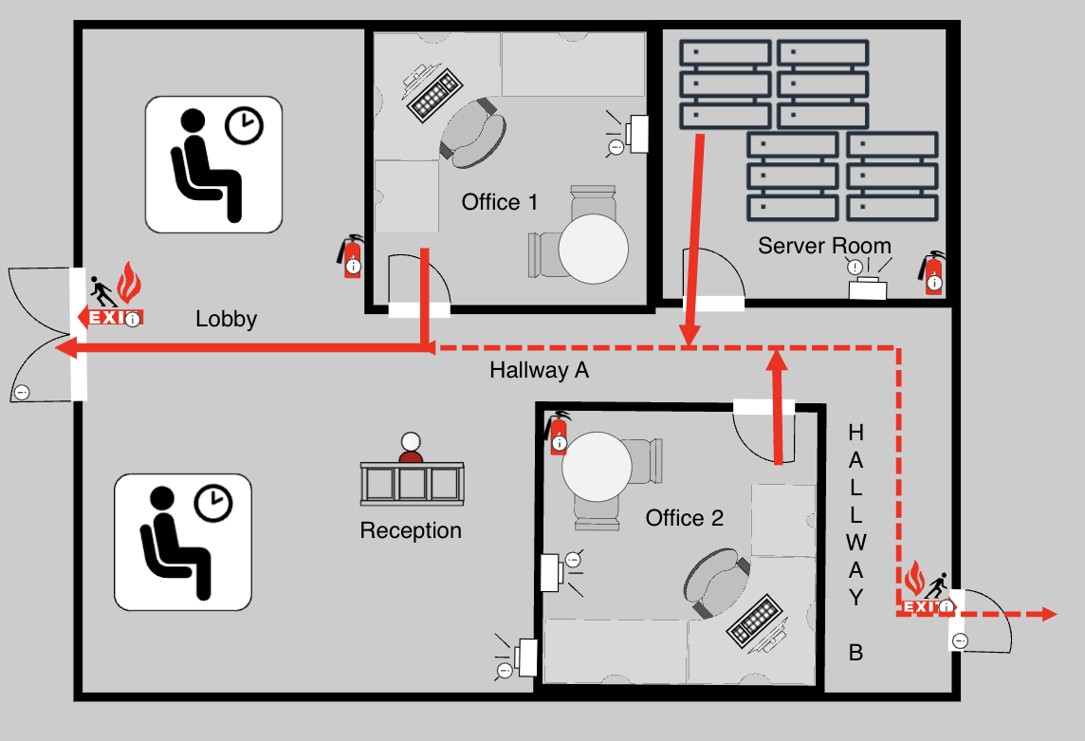
Fire evacuation routes and assembly points: Refer to the provided maps for detailed evacuation routes. All personnel should proceed to the designated area located at XXXX $%!#@& st.. This area serves as the rendezvous point for headcounts and further instructions.
Fire extinguisher locations and usage instructions: Ensure all employees are trained in the PASS method:
- Pull the pin
- Aim at the base of the fire
- Squeeze the handle
- Sweep side to side
Fire extinguishers are located in the main lobby area, Office 2, and the Server Room.
Communication protocols during fire emergencies:
- Announce the fire emergency clearly using the building's PA system or by word of mouth if necessary.
- Designate personnel to account for all persons at the assembly point – Admin A
- Immediately notify emergency services (Fire Department) – Admin B
- Inform stakeholders once the situation is stabilized – Admin C
Roles and responsibilities during fire incidents:
- Evacuation Coordinator: Oversees safe and orderly evacuation.
- Route Guides: Direct employees to the correct exits.
- Safety Officer: Verifies all areas are cleared and manages communication with emergency services.
Special considerations:
- For individuals unable to exit through normal means, use Section 3: Contingency Procedures in Fire Plan Procedures:
  - Identify the closest window.
  - Use a glass breaker if needed.
  - Set up a ladder or position an inflatable platform.
- Equipment requiring shutdown should be safely powered down if time and safety permits.
Post-fire assessment procedures:
- Conduct a roll call and verify all persons are accounted for.
- Inspect the building for damage (only once cleared by emergency services).
- Document the incident and initiate recovery protocols.
Documentation requirements:
- Complete incident report forms.
- Record evacuation time, any injuries, and actions taken.
- File documentation with the safety officer and leadership team.

1.2

FIRE PLAN PROCEDURES
- Evacuation Procedures
  - Identify the location and severity of the fire
    - If the fire is within the room and is manageable to quench via fire extinguisher, which will be determined by the authority figure present, refer to Section 2 for Fire Extinguishing Procedures
  - Leave the room through the nearest and safest exit door
    - If the room is unsafe to exit due to the fire or other conditions, please refer to Section 3 for Contingency Procedures
  - Locate the closest and safest staircase according to Table α
  - Descend that staircase to the ground floor
  - Locate the closest and safest exit door according to Table α and the staircase descended
  - Exit that door by pushing on the bar to open
  - Refer to Section 4 for Rendezvous Procedures
- Fire Extinguishing Procedures
  - The authority figure will locate and retrieve the closest fire extinguisher in the room
    - The authority figure may assign an employee to retrieve the fire extinguisher at their discretion.
  - The person holding the fire extinguisher will locate the fire and stand a safe distance away from the fire.
  - The person holding the fire extinguisher will follow the instructions on the fire extinguisher and attempt to extinguish the flames.
    - Most fire extinguishers will have instructions in the form of the acrynym P.A.S.S.
    - P – Pull the pin on the fire extinguisher. This will likely be labeled if it cannot be located.
    - A – Aim the nozzle towards the fire.
    - S – Squeeze the handle on the main tank to begin the flow of extinguishing foam.
    - S – Sweep the nozzle back and forth from one side of the fire to the other for appropriate coverage until the extinguishing foam stops flowing.
  - Once the person holding the fire extinguisher finishes following the instructions, assess the situation. If the fire has not been extinguished by the extinguishing foam, refer back to Section 1 to finish evacuation procedures.
- Contingency Procedures
  - If the primary exit door is blocked or otherwise unsafe to vacate, the authority figure present will locate the next safest exit door.
  - If no other safest exit doors exist, the authority figure will locate the closest safe window to exit.
  - The authority figure will operate the controls to open the window and begin chaperoning others in the room to start vacating.
    - The authority figure will assign one other to assist everyone else out.
    - If the window does not have any controls to open it, the authority figure will locate the nearest sturdy wieldable implement and clear the frame of glass.
      - If the window is on an elevated floor, refer to context sensitive instructions based on which room is being evacuated.
- Rendezvous Procedures
  - Once all individuals have safely evacuated the building, all personnel are to immediately report to XXXX $%!#@& st. for head counts.
  - Admin A will ensure that all persons present that day are safe and accounted for.
    - This list will be referrable on the company portal which is connected to the Clock In/Out system.
  - Admin B will call Emergency Services to request a response to put out the fire.
    - The building’s fire alarms are configured to contact Emergency Services after they have gone off for 30 seconds, but this call is also to ensure responders are on the way.
  - Admin C will contact stakeholders and higher personnel to report the fire and inform them on next steps.
  - Admin D will contact predetermined insurance agencies to report the incident.

1.3

FIRE PLAN CHECKLIST
Task | Signature | Date
Evacuation Completed
Head Count
Emergency Services Called
Insurance Company Contacted
Reporting Phase

Improvement Suggestions:
- Add more window evacuation tools (glass breakers, inflatable platforms, ladders)
- Provide training refreshers on evacuation plans and special procedures (e.g., protocol 1B)
BAMCIS:
- Begin planning
- Arrange reconnaissance
- Make reconnaissance
- Complete the plan
- Issue the order
- Supervise

Section 2

2.0

Employee Training Procedures and Frequency

Objective:
To ensure all employees understand and can effectively execute the procedures outlined in this playbook during a natural disaster or emergency situation. Regular training promotes safety, reduces confusion during emergencies, and increases the likelihood of a successful response and recovery.

Training Type | Frequency | Audience | Delivery Method

Fire Evacuation Drill | Semi-annually | All employees | In-person, hands-on

Emergency Roles & Responsibilities | Annually | Assigned staff (Admins A-D, Safety Officers, etc.) | In-person and online modules

PASS Fire Extinguisher Training | Annually | All employees | Hands-on simulation

Contingency Evacuation (Window/Non-standard exits) | Annually | Safety Officers, select floor leaders | Scenario-based drills

New Employee Orientation | Upon hire | New hires | Classroom session + digital training

Refresher Training | As needed (post-incident or update) | All employees | Online brief or physical meeting

Training Content Overview
Understanding the Green Book: Navigation, role references, checklists, and incident-specific sections.

Evacuation Protocols: Exit routes, maps, safe stairwells, and rendezvous point procedures.

Fire Response Roles: Duties of Evacuation Coordinators, Route Guides, Admins, and Safety Officers.

Use of Emergency Equipment: Proper handling of fire extinguishers and use of emergency window evacuation tools.

Contingency Planning: Actions when exits are blocked, window evacuation techniques.

Reporting and Communication Protocols: Proper channels for alerting emergency services, reporting to Admins, and post-incident documentation.

Attendance and Documentation
All training sessions will include a sign-in sheet and summary report submitted to the Safety Officer.

Completion of online modules will be tracked via the company Learning Management System (LMS).

Employees must sign an Acknowledgment of Training Completion Form after each annual session.

Non-compliance or repeated failure to attend will be reported to HR for follow-up.

Continuous Improvement
Feedback will be collected after each training via anonymous survey or form.

Suggestions for improvement or new training topics will be reviewed during quarterly safety reviews.

Training content will be updated annually or as major changes to the playbook occur.

Section 2: _______________ Response Plan
(Blank pages for future addition)

Section 3: _______________ Response Plan
(Blank pages for future addition)

Section 4: _______________ Response Plan
(Blank pages for future addition)

Section 5: _______________ Response Plan
(Blank pages for future addition)

Appendices

- Emergency contact information
- Incident report forms
- Equipment inventory
- Resource allocation templates
- Recovery procedures
- Training requirements and schedule
To get started right away, just tap any placeholder text (such as this) and start typing to replace it with your own.
Want to insert a picture from your files or add a shape, text box, or table? You got it! On the Insert tab of the ribbon, just tap the option you need.
Find even more easy-to-use tools on the Insert tab, such as to add a hyperlink or insert a comment.

