Setting Up a UFW

Emily Lovo
University of Advancing Technology
NTW216: System Administration 1
Aaron Jones
3/21/2024

Setting up a UFW
Screenshots of the setup
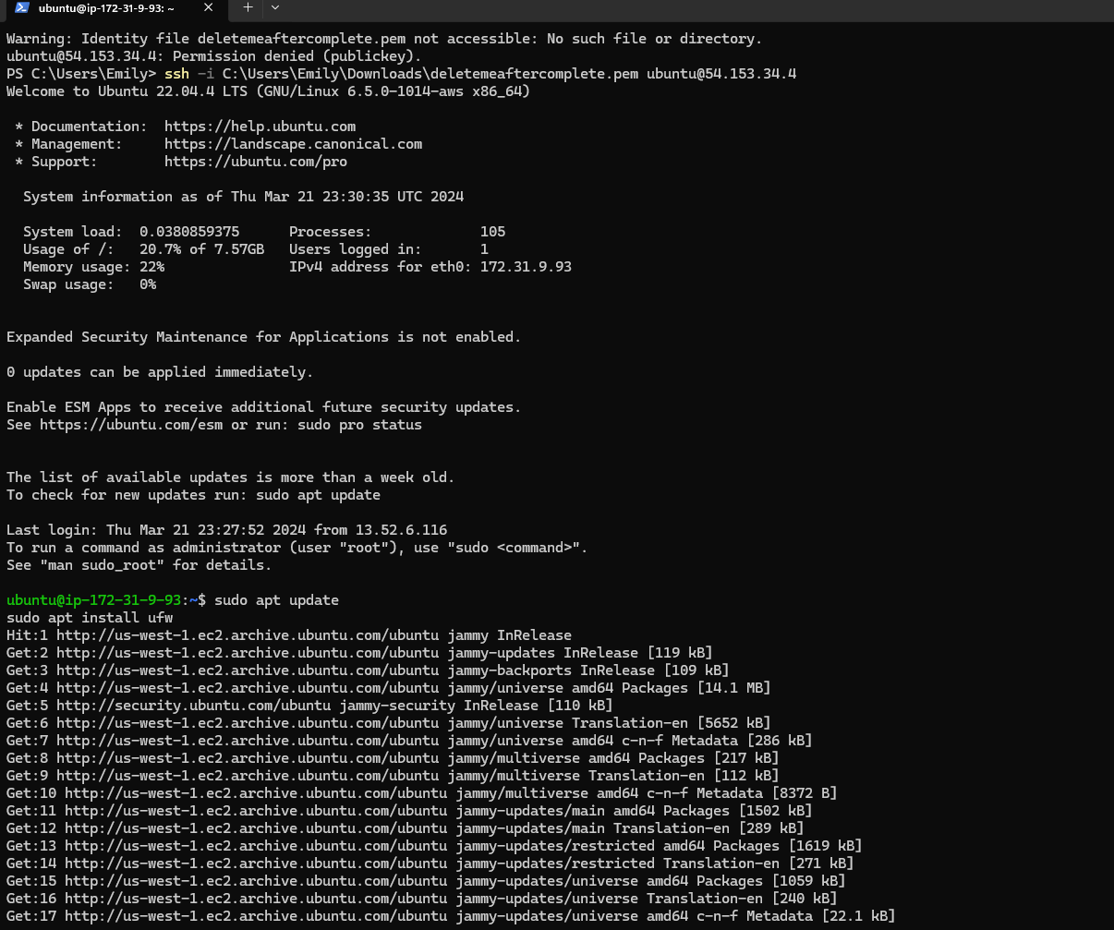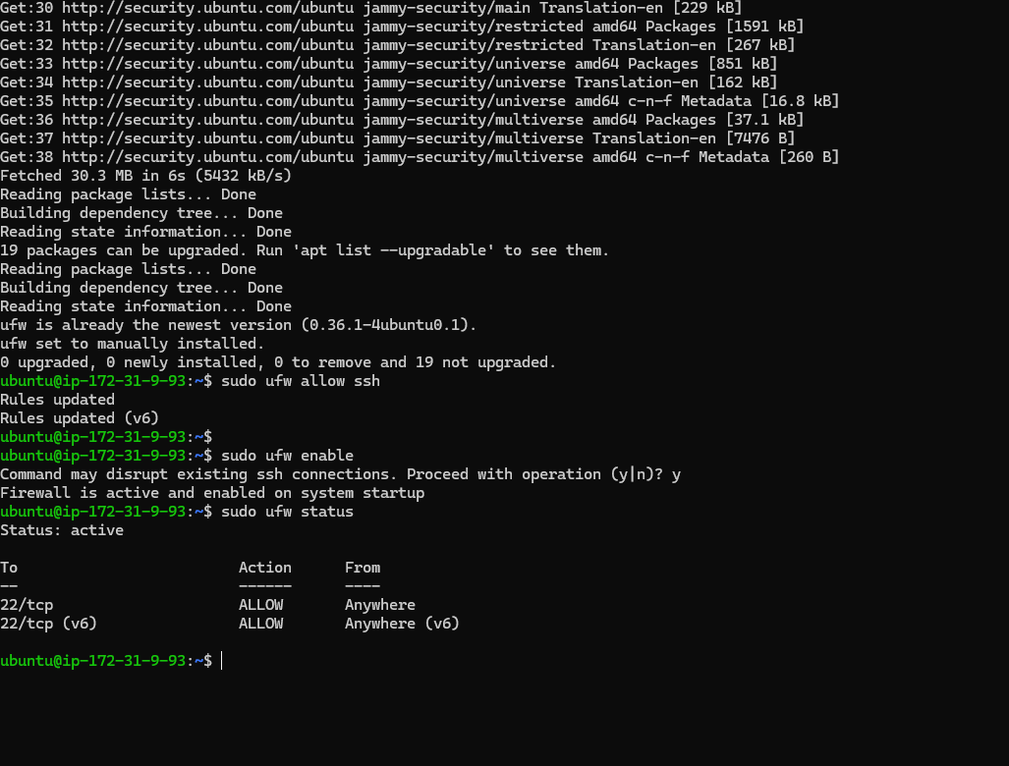

Reflection
Firewalls are an important tool for cyber management. They are a defensive barrier between trusted internal and untrusted external networks. They control incoming and outgoing network traffic based on pre-set security rules, thereby playing a crucial role in enhancing server security. Firewalls prevent unauthorized access, protect against malicious attacks, enforce network policies, safeguard sensitive data, and avoid security breaches. Firewalls are not just tools. They are your first line of defense against cyber-attacks. They play a significant role in maintaining compliance with regulations and controlling the risk of cyber threats. By filtering out incoming and outgoing traffic, firewalls can prevent cybercriminals from exploiting security vulnerabilities and causing damage. Firewalls are, therefore, crucial in safeguarding sensitive data and ensuring the integrity of the network, giving you the confidence that your network is secure.
Uncomplicated firewalls (UFWs) are more than just user-friendly front ends for managing IP tables. They are your key to simplified firewall management. With a simple and intuitive command-line interface, configuring firewall rules becomes a breeze. Administrators can define rules for allowing or denying traffic based on reports, IP addresses, and protocols. UFWs are designed to simplify enforcing security policies, making it easier for even those with limited network expertise to understand and configure. Using UFWs, firewall maintenance on Ubuntu systems becomes more than manageable. It becomes a strategic part of your cyber management. They remove the complexity of IP tables, allowing you to deploy and manage firewall rules quickly without extensive configuration. This makes the process of securing an Ubuntu server much more straightforward. UFWs provide an intuitive interface that enables you to manage firewall rules more effectively and efficiently, ensuring that servers remain protected against security breaches. In conclusion, firewalls and UFWs are not just tools. They are essential components in your cyber management strategy, which is crucial in maintaining the security and integrity of servers and networks.

References
Day, B. (2024, March 19). An introduction to UFW, ubuntu’s “uncomplicated” firewall. Linux Security. https://linuxsecurity.com/news/firewall/an-introduction-to-ufw-ubuntus-uncomplicated-firewall
Ubuntu documentation. UFW - Community Help Wiki. (n.d.). https://help.ubuntu.com/community/UFW
UncomplicatedFirewall. Ubuntu wiki. (n.d.). https://wiki.ubuntu.com/UncomplicatedFirewall
Understanding firewalls for home and small office use: CISA. Cybersecurity and Infrastructure Security Agency CISA. (2024, March 21). https://www.cisa.gov/news-events/news/understanding-firewalls-home-and-small-office-use#:~:text=Firewalls%20provide%20protection%20against%20outside,or%20network%20via%20the%20internet.

