IoT Smartphone Application Analysis of GoatDroid

Emily Lovo
University of Advancing Technology
NTW233: IoT Architecture and Security
Briant Becote
7/10/2025

Executive Summary
This is an analysis of the Gold Droid Android application using QARK, which stands for Quick Android Review Kit, on my Kali Linux system. The purpose was to identify vulnerabilities, particularly those involving cross-site scripting. The goal was to detect flaws in WebViews that accept invalid inputs and enable JavaScript, which can lead to the execution of malicious code. Using QARK, I analyzed the Gold Droid APK and found that it enabled JavaScript within WebViews in ten instances. One of the vulnerabilities identified was related to static code analysis and validation, which can be exploited using crafted intents containing malicious JavaScript. This report includes my installation steps, screenshots, confirmation of vulnerabilities, a code review, and mitigation strategies to prevent future exploitation.

Steps
Clone the Qark Repo
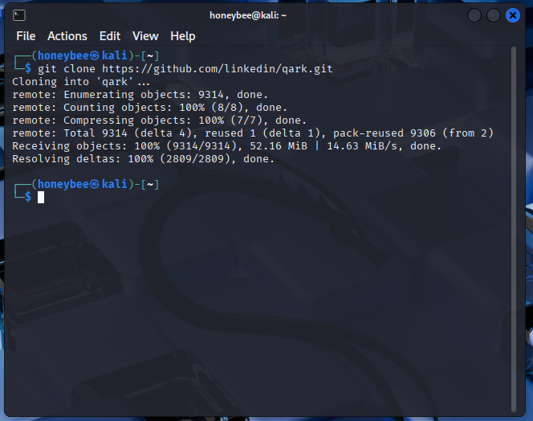
Verified Python version and Qark installation
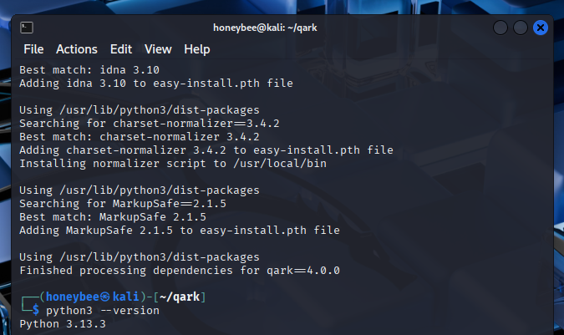
Find the APK location and run Qark against the APK
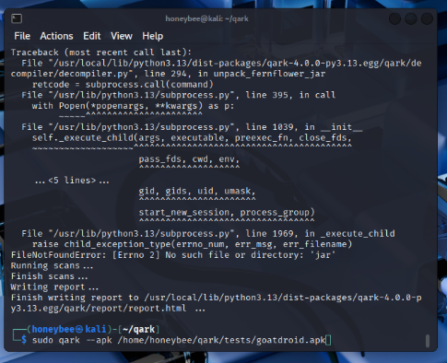
10 instances of JavaScript enabled in WebView
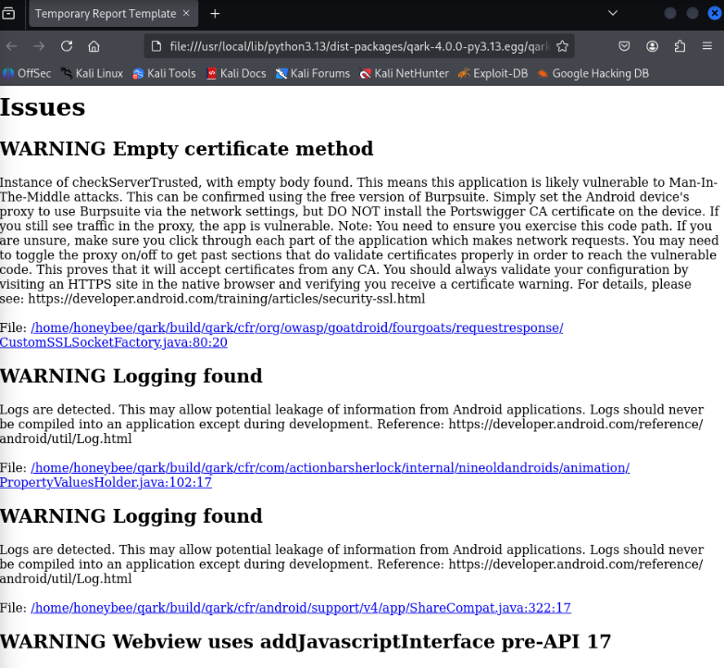

Vulnerability Confirmation
The code is vulnerable to cross-site scripting (XSS) because the WebView component has JavaScript enabled. This setting allows URLs to be processed directly without proper validation, opening the door for attackers to craft an intent that includes a malicious payload, such as a JavaScript alert for XSS. When the app processes this payload, it is executed within the WebView, allowing JavaScript to run in the app's context. This vulnerability can lead to various security issues, including phishing attacks, session hijacking, credential theft, and redirection to sites controlled by the attacker. To mitigate this vulnerability, JavaScript should be disabled unless necessary, and all incoming URLs should be validated using a trusted whitelist. The code is particularly at risk because, as noted, when JavaScript is enabled in a WebView and external inputs (like URLs) are loaded without validation, it becomes susceptible to JavaScript injection. Attackers can easily create a malicious intent that triggers harmful scripts, leading to data theft or manipulation within the app, according to ChatGPT.

Cross Site Scripting
Cross-site scripting (XSS) is a common but dangerous vulnerability that arises when malicious scripts are injected into web pages, impacting users who view those pages. This typically occurs when applications accept user-supplied data and render it onto a page without proper validation. Once injected, these scripts can hijack user sessions, steal sensitive information, deface websites, or even redirect users to malicious sites. There are four main types of cross-site scripting: stored, reflected, and DOM-based. Stored XSS: In this type, the payload is stored on the server and delivered to users when the page loads. Reflected XSS: Here, the payload is included in a request and immediately reflected in the server's response. DOM-based XSS: This type is handled entirely on the client side, where insecure JavaScript processes user inputs and modifies the Document Object Model (DOM). Several real-world examples highlight the severity of XSS attacks. For instance, in 2018, British Airways experienced a significant breach when a compromised third-party script led to the theft of sensitive data through malicious JavaScript injection. Another incident occurred in 2013 with Yahoo Mail, where attackers used XSS to steal email content via image-based scripts. To mitigate the risks associated with cross-site scripting, it is essential to follow best security practices. Always validate and sanitize all user inputs and use HTML encoding to escape special characters before rendering them on the page. Additionally, disable JavaScript and web views whenever possible, and only enable them when necessary. Avoid loading external scripts directly from user inputs, particularly if JavaScript is enabled, to reduce the risk of XSS vulnerabilities significantly.

Summary
I summarized my findings and discovered that I identified 10 web applications that utilize JavaScript, out of which at least one was considered vulnerable. The medication recommendations were consistent for all applications, regardless of their cost. It's important to disable JavaScript in web views by default, validate user inputs before loading content, and avoid allowing user control in security-sensitive applications. Additionally, JavaScript should only be enabled when necessary, and if it must be enabled, thorough validation should be performed rather than allowing it automatically.

References
OWASP Foundation. (n.d.). Cross Site Scripting (XSS). Retrieved from https://owasp.org/www-community/attacks/xss/
PortSwigger. (n.d.). Cross-site scripting (XSS). Retrieved from https://portswigger.net/web-security/cross-site-scripting
GitHub. (n.d.). LinkedIn QARK. Retrieved from https://github.com/linkedin/qark
OWASP GoatDroid Project. (n.d.). Retrieved from https://owasp.org/www-project-goatdroid/
ChatGPT. (2025, July 10). Assessment of XSS risk in Android WebView code. OpenAI.

